Assignment 2 Sales Order Database (Using Xampp)

Taylor Bolinger

Sales Order Table

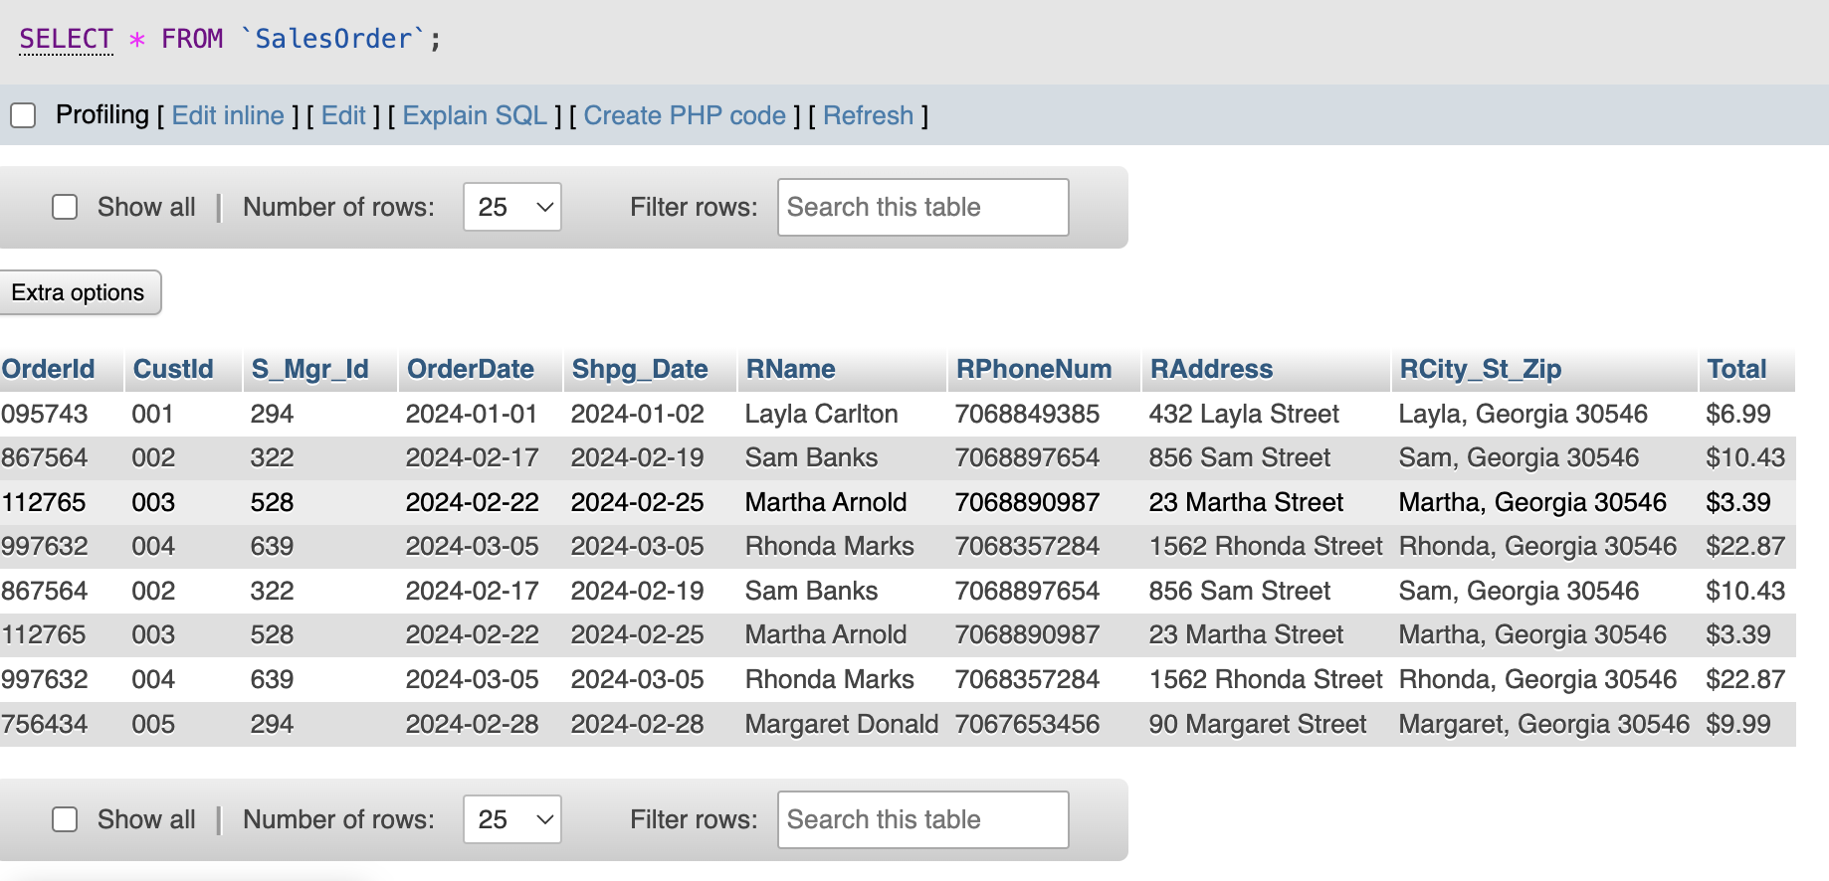

Customer Table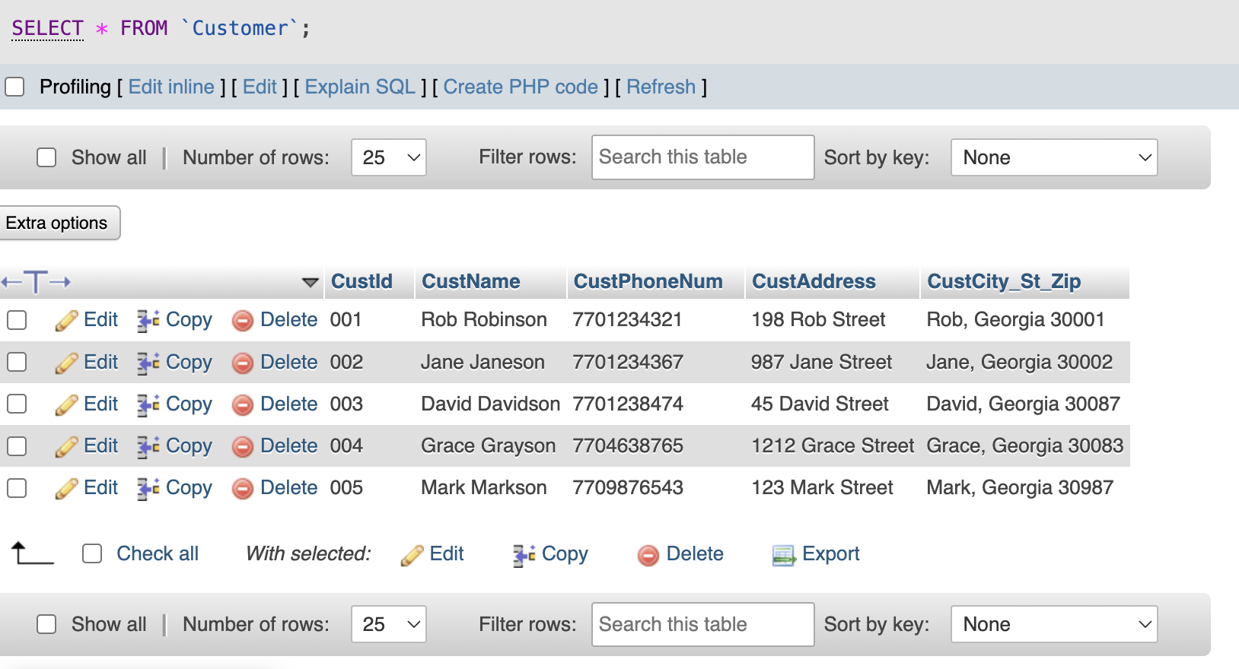

Salesman

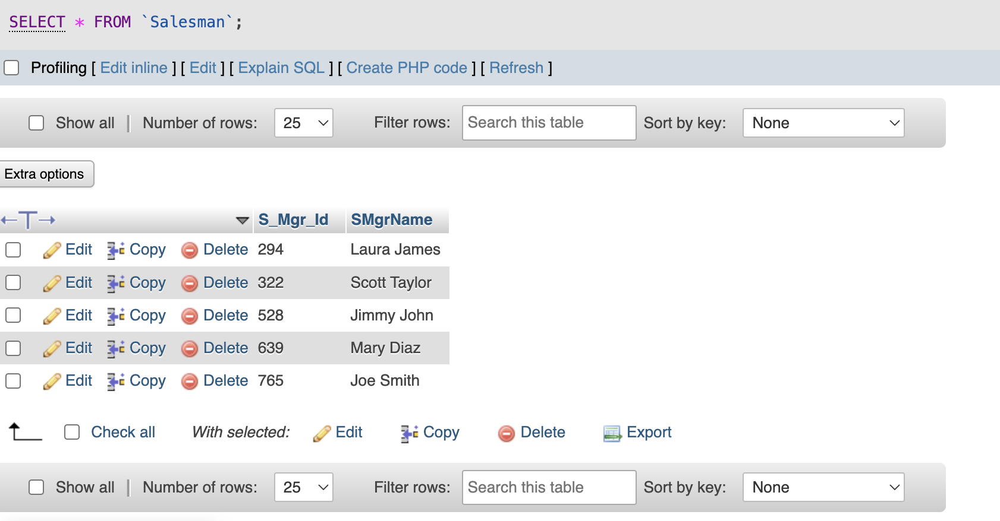

Product

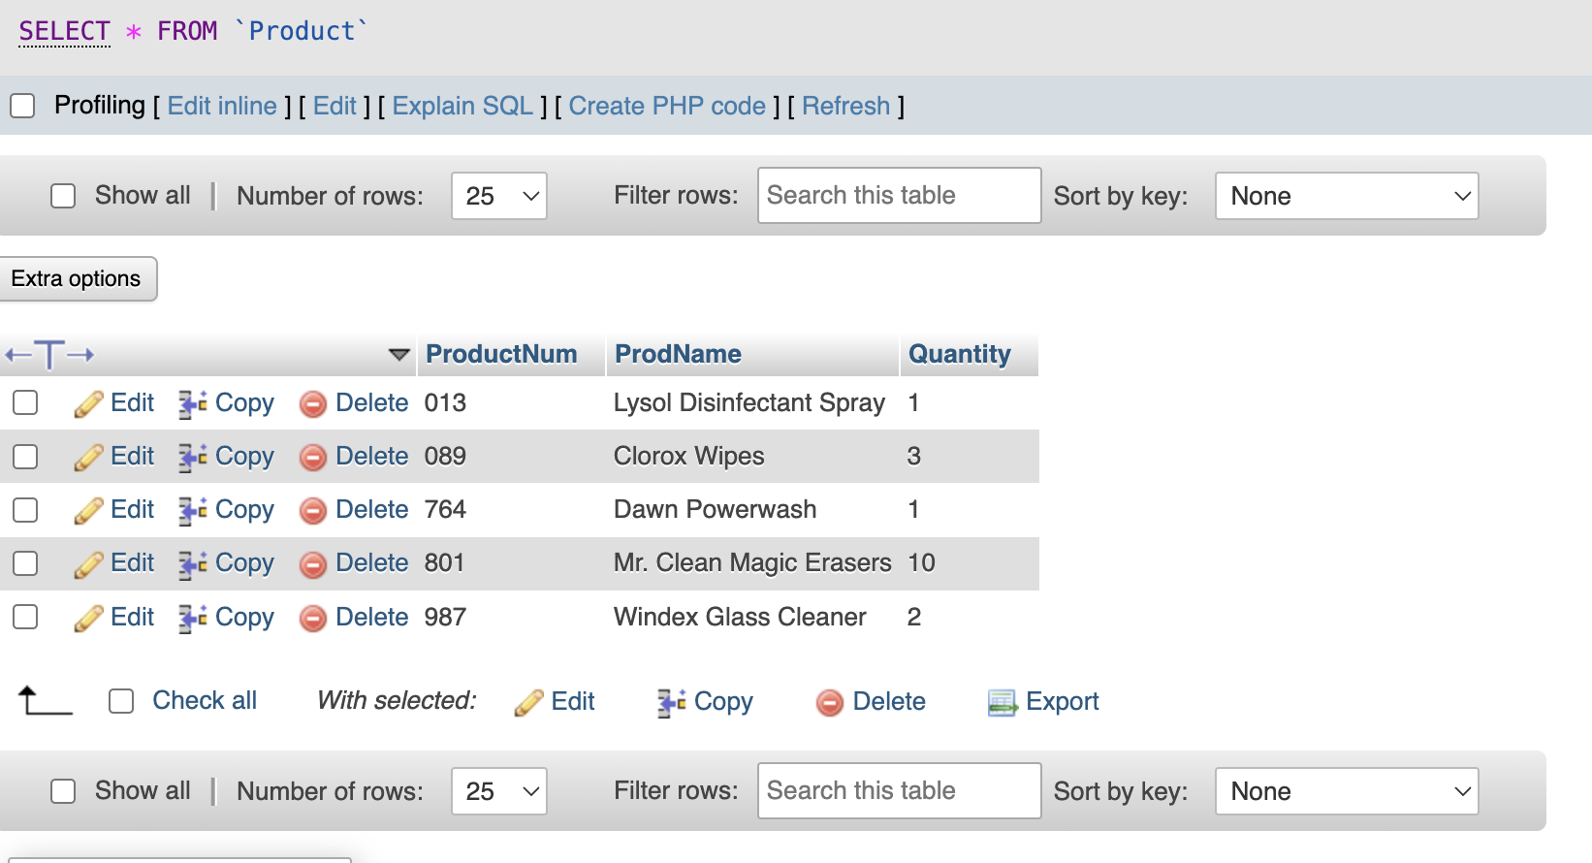

Manufacturer

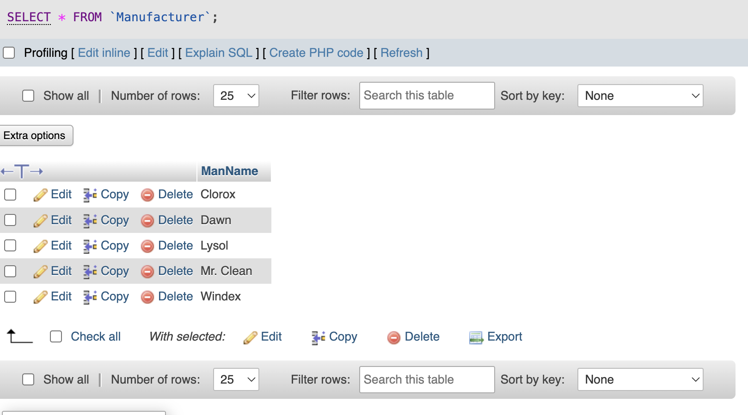

Unit Price

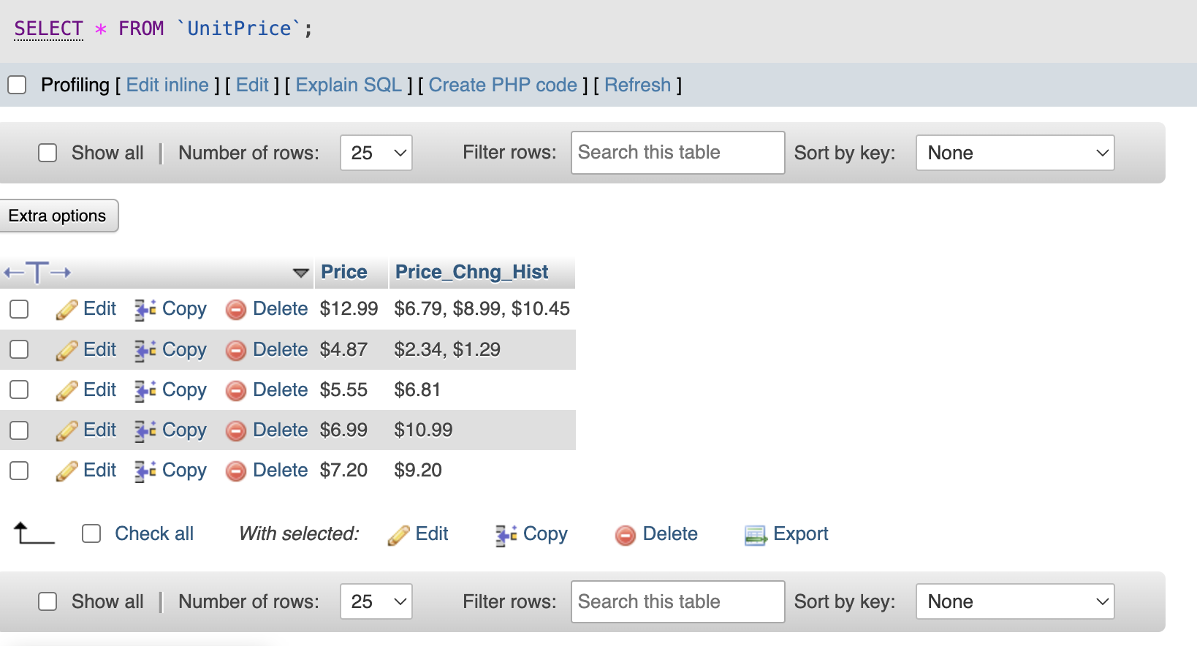

Where Condition (Sales Manager ID in Sales Order Table

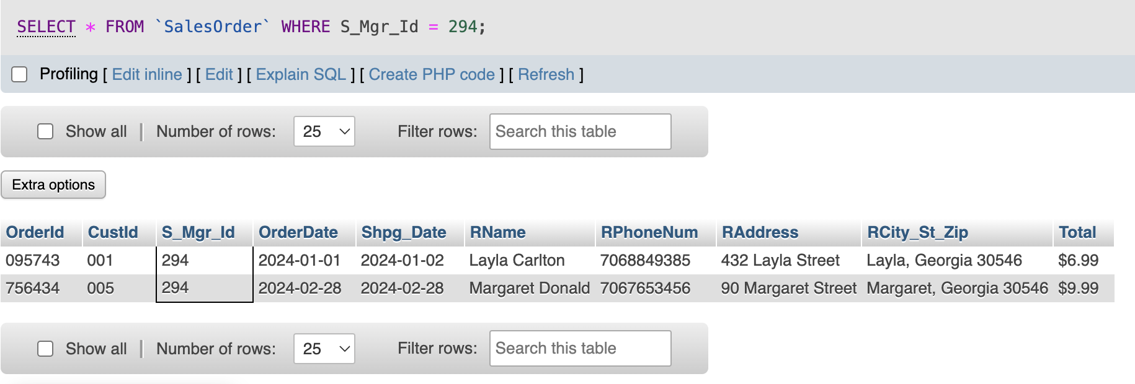

Order By (Customer Name by Descending Order in Customer Table)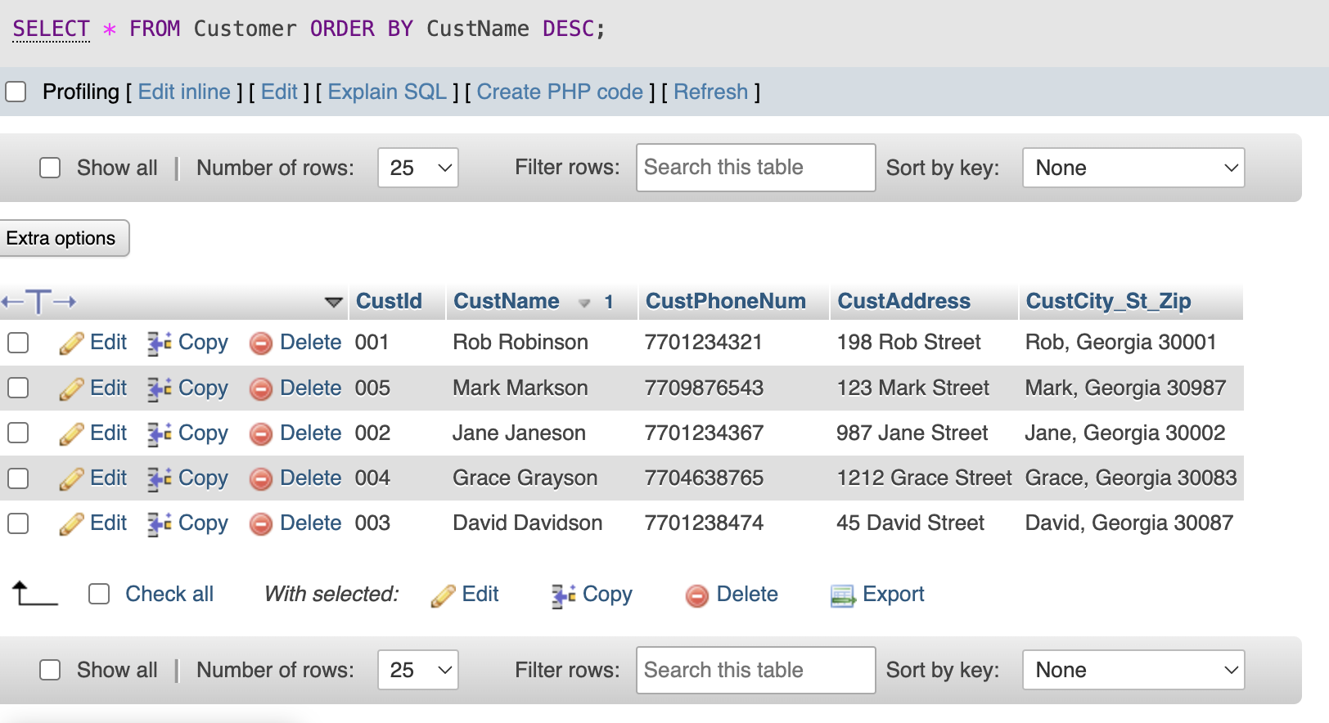

Group By (Number of Phone Numbers for Each Customer Name)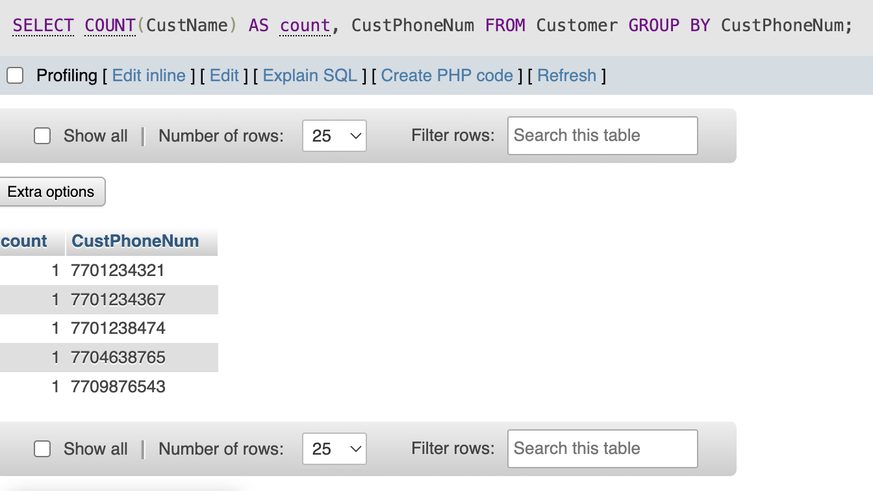

Having (Product Names Having More Than One Quantity)

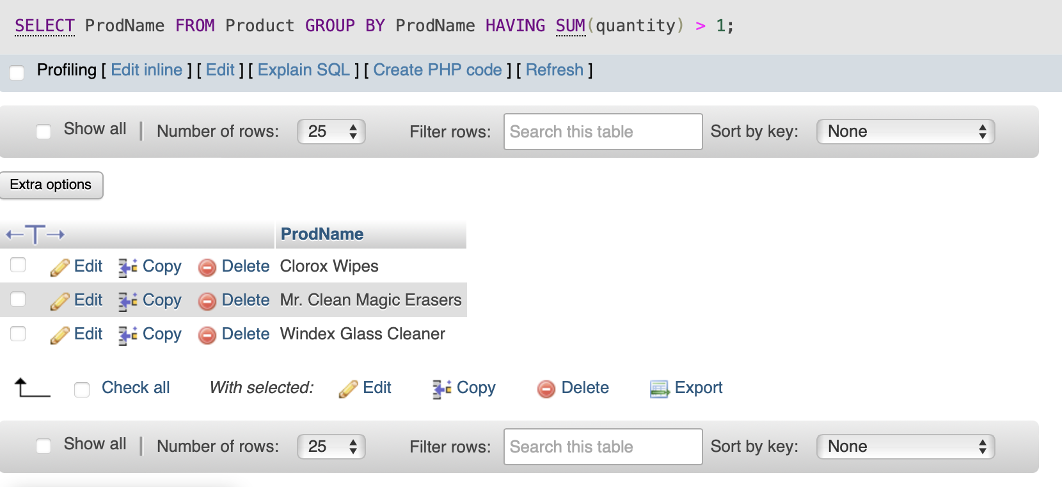

Join (Sales Order Table and Salesman by Sales Manager Id Column)

